Code

using System;

using System.Collections.Generic;

using System.ComponentModel;

using System.Data;

using System.Drawing;

using System.Linq;

using System.Text;

using System.Threading.Tasks;

using System.Windows.Forms;

namespace Library_Management

{

public partial class Form1 : Form

{

public Form1()

{

InitializeComponent();

}

private void button1_Click(object sender, EventArgs e)

{

int num1, num2, result;

num1 = Convert.ToInt32(textBox2.Text);

num2 = Convert.ToInt32(textBox3.Text);

result = num1 * num2;

textBox4.Text = Convert.ToString(result);

int disc;

disc = result * 5 / 100;

textBox5.Text = Convert.ToString(disc);

int a, b, amt;

a = Convert.ToInt32(textBox4.Text);

b = Convert.ToInt32(textBox5.Text);

amt = a - b;

textBox6.Text = Convert.ToString(amt);

int x, y, diff;

x = Convert.ToInt32(textBox1.Text);

y = Convert.ToInt32(textBox2.Text);

diff = x - y;

textBox7.Text = Convert.ToString(diff);

}

private void button2_Click(object sender, EventArgs e)

{

int days, fine;

days = Convert.ToInt32(textBox8.Text);

if (days <= 5)

fine = 5;

else if (days > 5 && days <= 10)

fine = 10 + days;

else if (days > 10)

fine = 20 + days;

else

fine = 0;

textBox9.Text = Convert.ToString(fine);

}

private void button4_Click(object sender, EventArgs e)

{

textBox1.Text = "";

textBox2.Text = "";

textBox3.Text = "";

textBox4.Text = "";

textBox5.Text = "";

textBox6.Text = "";

textBox7.Text = "";

textBox8.Text = "";

textBox9.Text = "";

textBox11.Text = "";

textBox12.Text = "";

richTextBox1.Text = "";

}

private void button3_Click_1(object sender, EventArgs e)

{

Environment.Exit(0);

}

}

}

Design

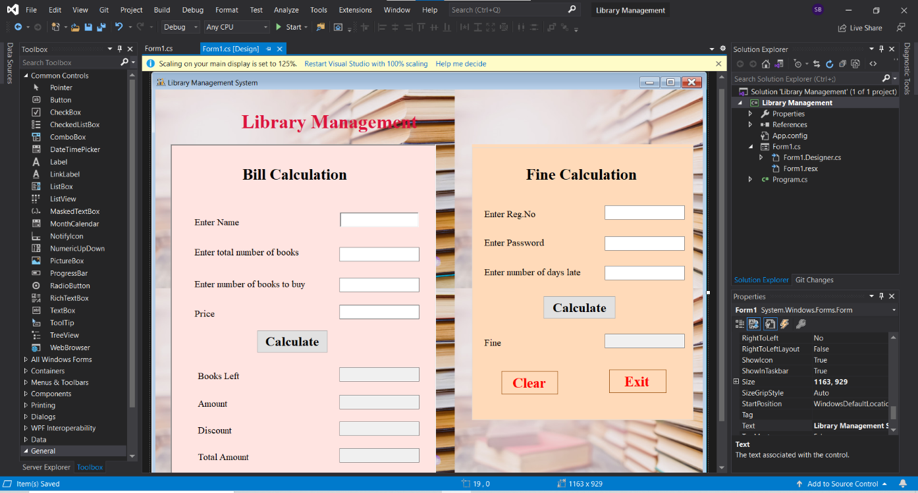

Output

